HW4 - Question 2 – AdaBoost

1. In this exercise we are given a decision stump for the following data:

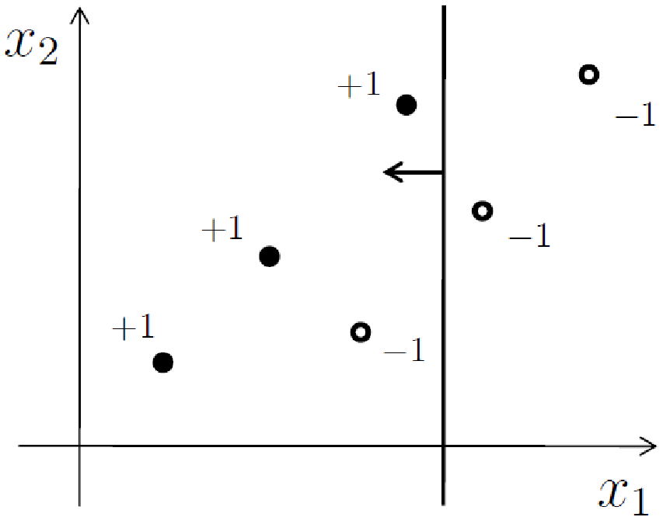

To visualize it as a stump, suppose the decision threshold is $T$:

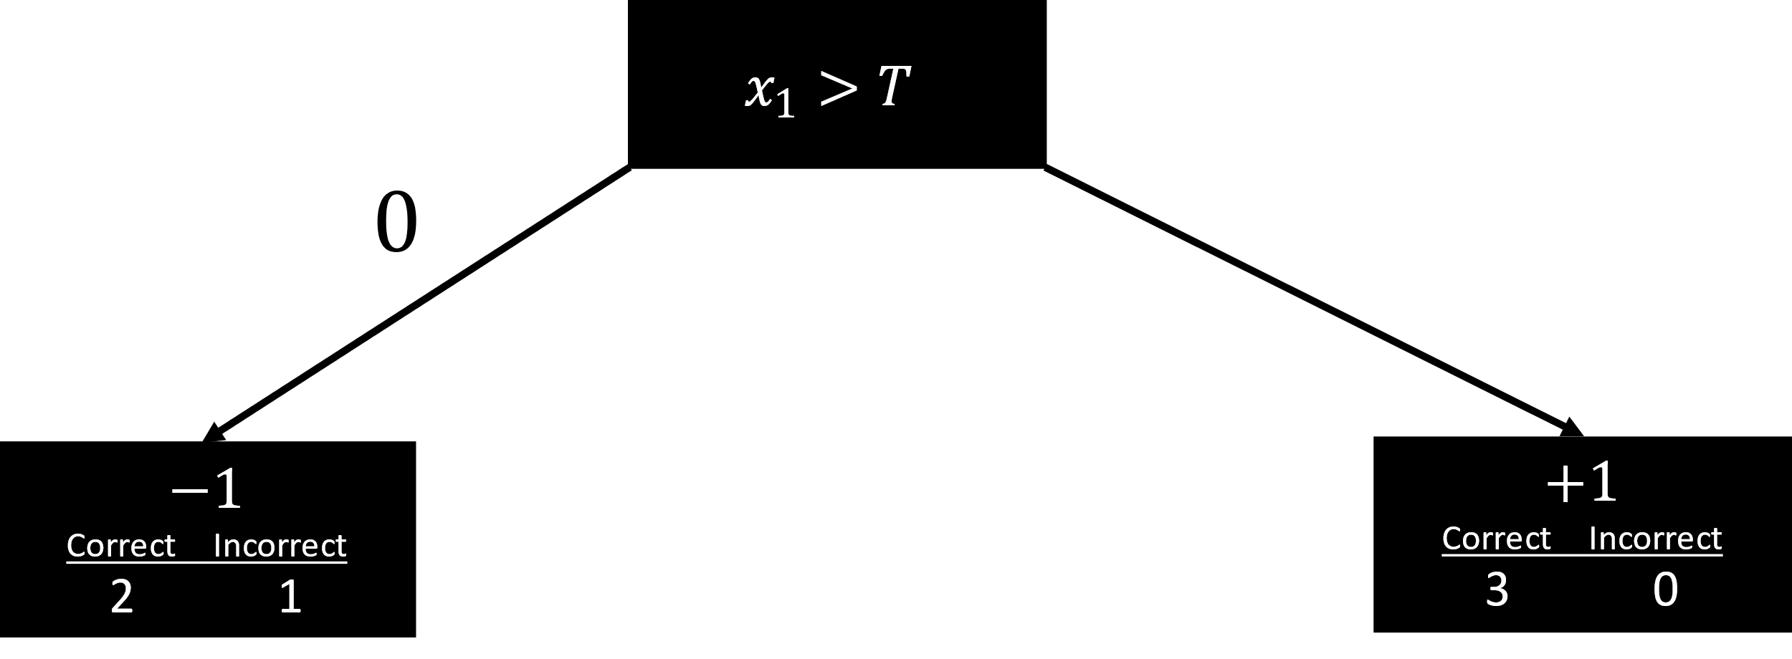

The current decision boundary fails on one occasion when classifying $-1$ as $+1$.

On the first iteration of AdaBoost each sample receives an equal weight, and since there are 6 samples each sample is weighted $\frac{1}{6}$. One sample was misclassified so the error is $\frac{1}{6}$.

$$ε_{1}=\frac{1}{6}$$

We use the following formula for finding the weight for the current stump:

$$a_{1}=\frac{1}{2}\log\left(\frac{1-ε_{1}}{ε_{1}}\right)=\frac{1}{2}\log\left(5\right)≅0.349$$

1. Let’s calculate the new weights for the samples, since one of the $-1$ samples got wrongly classified it would have a greater weight.



The sample that got misclassified.

We will use the formula to update the weights and then normalize it so the weights add up to 1.

$$d_{t+1}\left(x_{i}\right)=d_{t}\left(x_{i}\right)∙e^{-a_{t}y_{i}f_{t}(x_{i})}$$

Basically, for every **correct** sample we update the weights like so:

$$d_{2}\left(x_{i}\right)=d_{1}\left(x_{i}\right)∙e^{-a_{1}}=\frac{1}{6}∙e^{-0.349}≅0.117$$

And for every **incorrect** sample we update the weights like so:

$$d_{2}\left(x_{i}\right)=d_{1}\left(x_{i}\right)∙e^{-a_{1}}=\frac{1}{6}∙e^{0.349}≅0.236$$

To normalize the new weights, we’ll divide the total sum of weights out of each weight:

$$d_{2}\left(x\right)=5∙0.117+1∙0.236=0.821$$

So, for every correctly classified sample the new weight is $\frac{0.117}{0.821}=0.142$, and for the incorrectly classified sample the new weight is $\frac{0.236}{0.821}=0.287$, depicted in the following figure:



$$0.287$$

$$0.142$$

$$0.142$$

$$0.142$$

$$0.142$$

$$0.142$$

New weights for each sample added in red.

1. The new stump could use the following boundary:

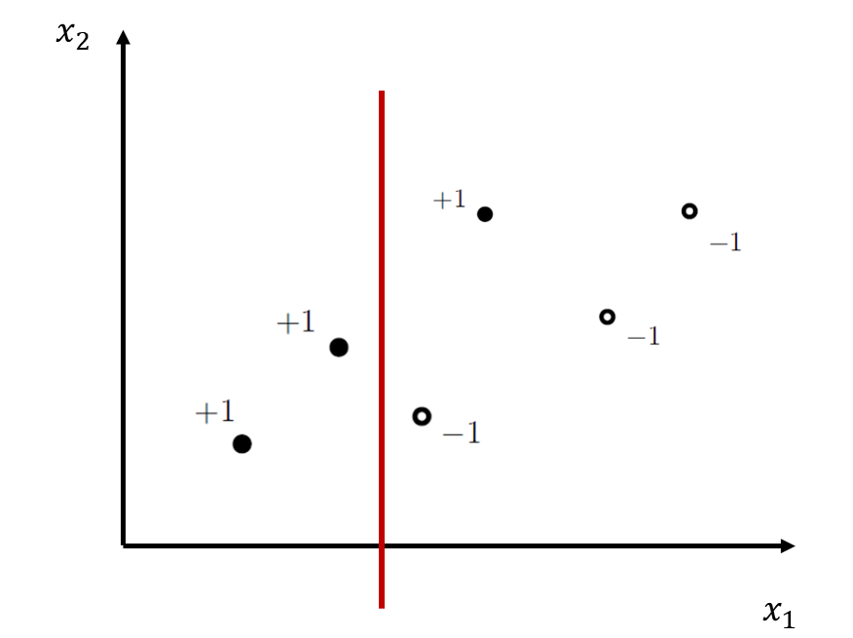

The stump would look like this:

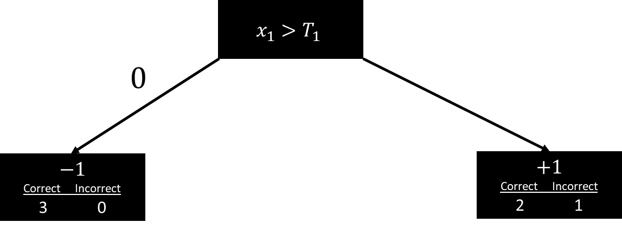

1. $a_{2}$ would have a larger classifier weight. $ε_{2}$ is going to be smaller than the first error since we incorrectly classified a sample with a lower weight than before, that means the formula for calculating $a_{2}$ would yield a greater result since it is a logarithmic formula.
2. It looks like the blue line would be a better decision stump because it has a lower error rate.

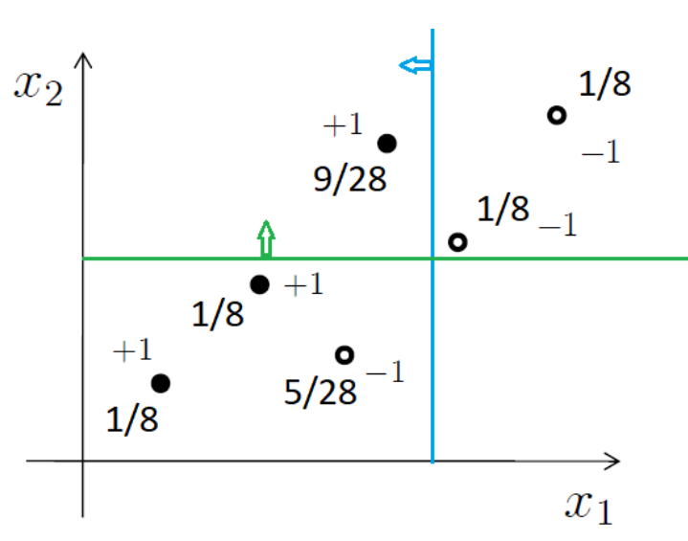

1. We know that: $a_{1}=0.349, a_{2}=1.1, a_{3}=0.62$, we can calculate the final classifier using:

$$a_{1}*h_{1}+a_{2}*h_{2}+a_{3}*h_{3}=0.349*h_{1}+1.1*h_{2}+0.62*h_{3}$$

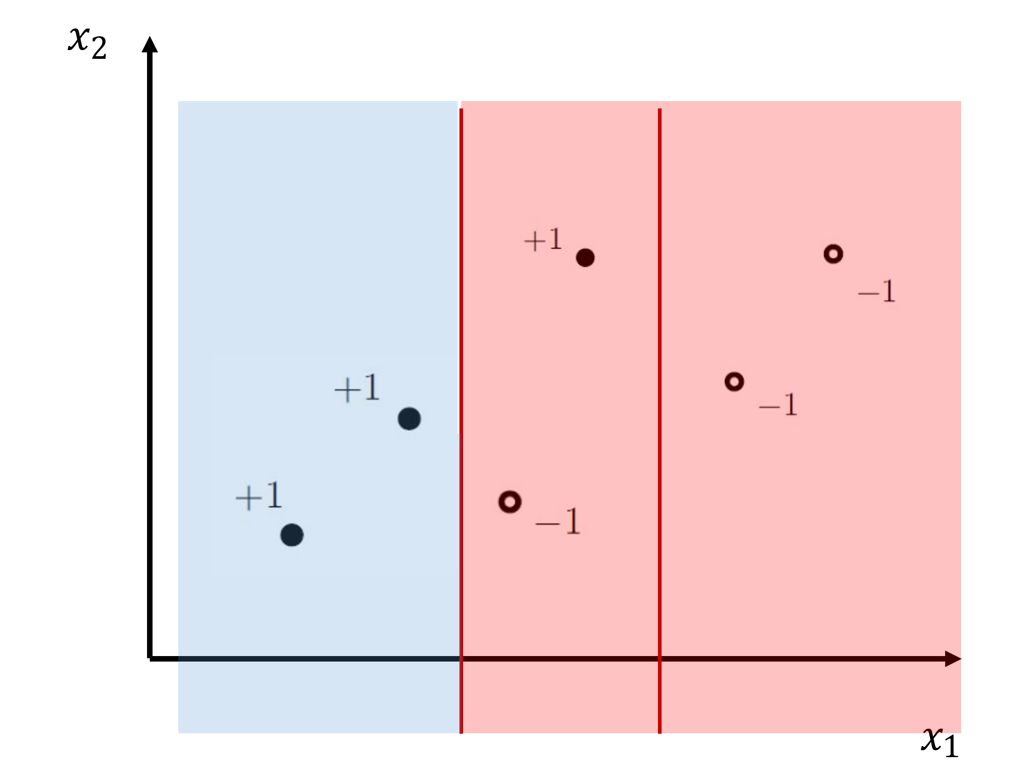

In the figure the areas were decided by what classifier was ‘heavier’ in each of them.

For illustration purposes here is the calculation:

|  |  |  |  |  |  |  |  |
| --- | --- | --- | --- | --- | --- | --- | --- |
| Sign( | $$0.349*$$ |  | $$1.1*$$ |  | $$0.62*$$ |  | ) |

The accuracy for the final classifier is $\frac{5}{6}$ since it misclassifies one sample.